**DRIVER DROWSINESS DETECTION USING MACHINE LEARNING**

**TABLE CONTENTS**

1. ABSTRACT
2. INTRODUCTION 3.EXISTING SYSTEM 4.PROPOSED SYSTEM 5.FACTS AND STATISTICS
3. SYSTEM REQUIREMENTS SOFTWARE ENVIRONMENT WORKING ENVIRONMENT
   * HARDWARE CONFIGURATION
   * SOFTWARE CONFIGURATION
4. SYSTEM FLOW DIAGRAM
5. LIBRARIES USED
6. PROBLEM DEFINITION
7. UML DIAGRAMS
8. IMPLEMENTATION
9. CONCLUSION
10. FUTURE SCOPE
11. REFERENCES

# ABSTRACT:

In this project, we are going to build a driver drowsiness detection system that will detect if the eyes of the driver are close for too long and infer if the driver is sleepy or inactive. This is an important safety implementation as studies suggest that accidents due to drivers getting drowsy or sleepy account for around 20% of all accidents and on certain long journey roads it’s up to 50%. There has been an increase in safety systems in cars & other vehicles and many are now mandatory in vehicles, but all of them cannot help if a driver falls asleep behind the wheel even for a brief moment. Therefore, there is a need to develop the systems that will detect and notify a driver of her/him bad psychophysical condition, which could significantly reduce the number of fatigue-related car accidents. However, the development of such systems encounters many difficulties related to fast and proper recognition of a driver’s fatigue symptoms. One of the technical possibilities to implement driver drowsiness detection systems is to use the vision-based approach. This article presents the currently used driver drowsiness detection systems. Here we are detecting the driver drowsiness by estimating vision system of him/her .

# INTRODUCTION

Improvement of public safety and the reduction of accidents are the important goals of the Intelligent Transportation Systems (ITS). One of the most important factors in accidents, especially on rural roads, is driver fatigue and monotony. Fatigue reduces driver perceptions and decision-making capability to control the vehicle. Researches show that usually, the driver is fatigued after 1 hour of driving. In the afternoon early hours, after eating lunch, and at midnight, driver fatigue and drowsiness are much more than at other times. In addition, drinking alcohol, drug addiction, and using hypnotic medicines can lead to loss of consciousness

In different countries, different statistics were reported about accidents that happened due to driver fatigue and distraction. Generally, the main reason for about 20% of the crashes and 30% of fatal crashes is driver drowsiness and lack of concentration. In single-vehicle crashes (accidents in which only one vehicle is damaged) or crashes involving heavy vehicles, up to 50% of accidents are related to driver hypervigilance. According to the current studies, it is expected that the number of crashes will be reduced by 10%–20% by using driver face monitoring systems

In the driver face monitoring systems, the main challenge can be considered as how to measure the fatigue? One of the first and most important symptoms of fatigue appears in the eye. Almost in all driver face monitoring systems, eye closure detection is the first symptom used to measure fatigue.

# EYE BLINK MEASUREMENT :

Similar to the yawning-based method a camera records the driver’s face and checks if the driver’s eyes are closed or open. The estimated average blinking duration is between 100-400ms according to the Harward database of useful biological numbers.

If the camera sees that the eye of the driver closes for a duration far more than that it marks the driver as asleep and some sort of alarm raised. This method has proven to be the most effective measure and easiest to implement providing satisfactory results.

# ABOUT FATIGUE DRIVING :

In research in this area actively now, there has been the fatigue detector that can be divided into contact and non-contact types in the market, the principles are as follows.

# FATIGUE CAN CAUSE EEG CHANGES :

The EEG is not on the performance of the same when the cerebral cortex is in excitement or inhibition. According to the EEG's frequency distribution and waveforms, assumes the function status of the brain activity, so as to speculate whether the driver is fatigued. However the EEG is vulnerable to interference from external factors and there are so many differences in individual physiological response

# HEAD POSTURE :

When the driver is fatigued, the head will downward sloping. According to statistics, the correlation coefficient of head position and fatigue degree is about 0.8. However, drivers’ head posture will not change basically, the correlation coefficient will be negative and the system's judge and early warning failed.

# STEERING WHEEL’S ROTATION AMPLITUDE AND HANDGRIP STRENGTH :

System detects the driver's mental state by monitoring steering wheel's movements and patterns. With the deepening of the driver fatigue, the number of greatly rotation will be increase; the handgrip strength will become larger.

# OBJECTIVE OF THE FATIGUE DETECTION

How to effectively monitor and prevent driver fatigue driving has much real significance to reduce traffic accidents and personnel mortality . After Comparison of the above fatigue alarm, the system through many studies of the driver's eyes, the research work in this paper include the four parts, i.e., Driver’s face detection, Driver’s eye locating and tracking, Driver’s eye state recognition and Driver’s fatigue state identification.

# EXISTING SYSTEM

An important factor for causing accidents in traffic that the driver's fatigue. Many countries are engaged in research in this area actively now. How to effectively monitor and prevent driver fatigue driving has much real significance to reduce traffic accidents and personnel mortality. When the driver is fatigued, the head will always downward-sloping. According to statistics, the correlation coefficient of head position and fatigue degree is about 0.8. However, some driver's head posture will not change basically, the correlation coefficient will be negative and the system's judge and early warning failed. System detects the driver's mental state by monitoring steering wheel's movements and patterns. With the deepening of the driver fatigue, the number of greatly rotation will be increase; the handgrip strength will become larger. This method monitors the time and the deviation degree of vehicles leaving from the white lines by installing camera in the same perspective with the driver on the vehicle. This measurement requires the white line must be exist and clear enough on the road, so the interference of outside conditions is very great.

The EEG is not on the performance of the same when the cerebral cortex is in excitement or inhibition. According to the EEG's frequency distribution and waveforms, assumes the function status of the brain activity, so as to speculate whether the driver is fatigued. However the EEG is vulnerable to interference from external factors and there are so many differences in individual physiological response.The existing system of driver drowsiness detection system has following disadvantages. Mainly, using of two cameras in the system one for monitoring the head movement and the other one for facial expressions.The other disadvantage is aging of sensors and all these sensors are attached to the driver’s body which may affect the driver. So to overcome all these disadvantages we designed a system in which a live camera is used for monitoring the driver drowsiness condition and alert the driver which reduces the road accidents.

# PROPOSED SYSTEM

In this project we are developing a driver drowsiness detection with details about how to calculate the fatigue of the driver that will detect if the eyes of the driver are close for too long and infer if the driver is sleepy or inactive.

The system can check the movements of the drivers continuously.

* Alert messages will be displayed on the screen.
* Alarm tone will be played if the driver found sleepy.

# FACTS & STATISTICS

Our current statistics reveal that just in 2021 in India alone, 148,707 people died due to car related accidents. Of these, at least 21 percent were caused due to fatigue causing drivers to make mistakes. This can be a relatively smaller number still, as among the multiple causes that can lead to an accident, the involvement of fatigue as a cause is generally grossly underestimated. Fatigue combined with bad infrastructure in developing countries like India is a recipe for disaster. Fatigue, in general, is very difficult to measure or observe unlike alcohol and drugs, which have clear key indicators and tests that are available easily. Probably, the best solutions to this problem are awareness about fatigue-related accidents and promoting drivers to admit fatigue when needed. The former is hard and much more expensive to achieve, and the latter is not possible without the former as driving for long hours is very lucrative. When there is an increased need for a job, the wages associated with it increases leading to more and more people adopting it. Such is the case for driving transport vehicles at night. Money motivates drivers to make unwise decisions like driving all night even with fatigue. This is mainly because the drivers are not themselves aware of the huge risk associated with driving when fatigued. Some countries have imposed restrictions on the number of hours a driver can drive at a stretch, but it is still not enough to solve this problem as its implementation is very difficult and costly

# SYSTEM REQUIREMENTS

**SOFTWARE REQUIREMENTS**

## Python:

Python 3

* + **Libraries:** Numpy Scipy Playsound Dlib Imutils Opencv

## Operating system:

Windows

# HARDWARE REQUIREMENTS

* + Web camera
  + Laptop with basic hardware

# REQUIREMENT ANALYSIS:

* + **Python:** Python is the basis of the program that we wrote. It utilizes many of the python libraries.

# LIBRARIES:

* + **Numpy**: Pre-requisite for Dlib
  + **Scipy**: Used for calculating Euclidean distance between the eyelids.
  + **Playsound:** Used for sounding the alarm
  + **Dlib**: This program is used to find the frontal human face and estimate its pose using 68 face landmarks.
  + **Imutils**: Convenient functions written for Opencv.
  + **Opencv:** Used to get the video stream from the webcam, etc.
  + **OS**: Program is tested on Windows 11
  + **Laptop**: Used to run our code.
  + **Webcam:** Used to get the video feed.

# SYSTEM FLOW CHART

During this project, the algorithm which we are using is fast as compared to the PERCLOS. PERCLOS is the percentage of eyelid closure over the pupil over time and reflects slow eyelid closures (“droops”) rather than blinks. A PERCLOS drowsiness metric was established in a 1994 driving simulator study as the proportion of time in a minute that the eyes are at least 80 percent closed. Therefore the time taken by our system is a smaller amount, Hence this technique is fast and can issue a warning within the variety of sound.

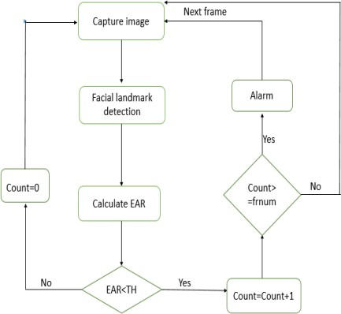

# LIBRARIES USED

This project focuses on two libraries OpenCV and Dlib and also on a mathematical concept called Eye Aspect Ratio (EAR):

* + - Opencv
    - Dlib
    - Imutils
    - Scipy
    - Playsound

# OPENCV

OpenCV is a huge open-source library for computer vision, machine learning, and image processing. OpenCV supports a wide variety of programming languages like Python, C++, Java, etc. It can process images and videos to identify objects, faces, or even the handwriting of a human. When it is integrated with various libraries, such as [Numpy](https://www.geeksforgeeks.org/python-numpy/) which is a highly optimized library for numerical operations, then the number of weapons increases in your Arsenal i.e whatever operations one can do in Numpy can be combined with OpenCV.

## DLIB

Dlib is a modern C++ toolkit containing machine learning algorithms and tools for creating complex software in C++ to solve real-world problems. It is used in both industry and academia in a wide range of domains including robotics, embedded devices, mobile phones, and large high-performance computing environments. Dlib's [open source licensing](http://dlib.net/license.html) allows you to use it in any application, free of charge. Dlib contains a wide range of machine learning algorithms. All designed to be highly modular, quick to execute, and simple to use via a clean and modern C++ API. It is used in a wide range of applications including robotics, embedded devices, mobile phones, and large high performance computing environments.

## MAJOR FEATURES:

* + Documentation
  + High-Quality Portable Code
  + Machine Learning Algorithms
  + Numerical Algorithms
  + Graphical Model Inference Algorithms
  + Image Processing
  + Threading
  + Networking
  + Graphical User Interfaces
  + Data Compression and Integrity Algorithms
  + Testing
  + General Utilities

# IMUTILS:

A series of convenience functions to make basic image processing functions such as translation, rotation, resizing, skeletonization, and displaying Matplotlib images easier with OpenCV and both Python 2.7 and Python 3.

Imutils is a package based on OpenCV, which can call the OpenCV interface more simply. It can easily realize a series of operations such as image translation, rotation, scaling, skeletonization, and so on. Compared with the original CV, using miles can directly specify the translated pixels without constructing the translation matrix. The resize function of imutils maintains the aspect ratio and provides the keyword arguments width and height so the image can be resized to the intended width/height.

# SCIPY:

SciPy is a scientific computation library that uses NumPy. SciPy contains varieties of sub-packages that help to solve the most common issue related to Scientific Computation. SciPy package in Python is the most used Scientific library only second to GNU Scientific Library for C/C++ or Matlab . Easy to use and understand as well as fast computational power.

It can operate on an array of NumPy libraries. Like NumPy, SciPy is open source so we can use it freely. It has optimized and added functions that are frequently used in NumPy and Data Science. SciPy module in Python is a fully-featured version of Linear Algebra while Numpy contains only a few features. Most new Data Science features are available in Scipy rather than Numpy.

# PLAYSOUND:

It is an easy task to play sound using Python script, because this language contains many modules to use script in order to to play or record sound. By using these modules, you can play audio files such as mp3, wav, and other audio file types. You must first install the sound module before using the module in the script. This tutorial will show how to install different types of Python modules to play sound.

The playsound module contains only one thing the function playsound(). It requires one argument the path to the file with the sound you would like to play. This may be a local file, or a URL. There’s an optional second argument, block, which is set to True by default. Setting it to False makes the function run asynchronously. On Windows, uses windll.winmm. WAVE and MP3 have been tested and are known to work. Other file formats may work as well. The playsound module is a cross platform module that can play audio files. This doesn’t have any dependencies, simply install with pip in your virtualenv and run.

# Eye Aspect Ratio (EAR) :

Eye aspect ratio is the ratio of height to width of the eye. When a face is given as input, python's dlib library outputs 68 points on the face as shown in the figure given below:

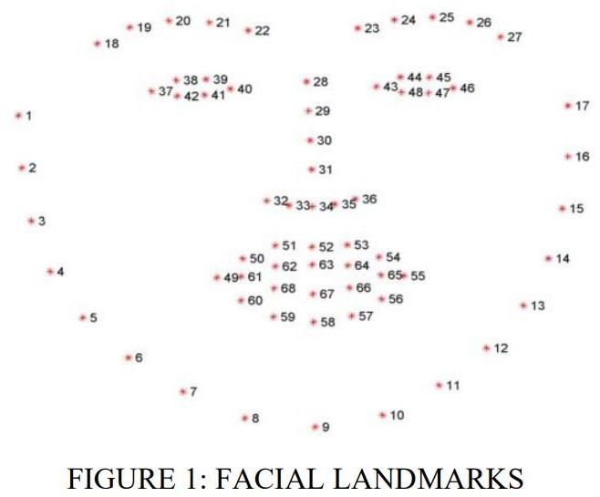

For eye region we need to consider the points from 37-46. Eye aspect ratio can be defined by the following equation:

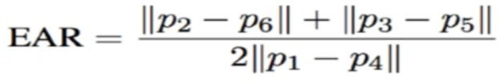

EAR is approximately constant while the eye is open and will immediately fall to zero when the eye is closed.

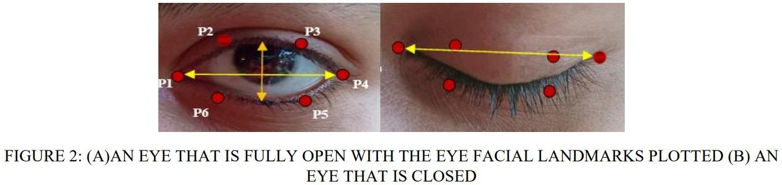

The eye aspect ratio will be monitored to see if the value falls but does not increase again, thus verifying that the person has closed their eyes. The following figure shows the block diagram for drowsiness detection.

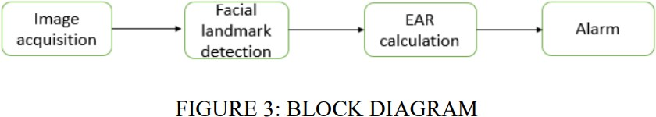

1. Image acquisition: Image is captured by the camera as frames.
2. Facial landmark detection: Using python's dlib library facial land mark detection is done. After that the eye region is extracted.
3. EAR calculation: EAR is calculated to determine if the eye is closed or not.
4. Alarm: If the eye is closed for sufficiently long period of time an alarm is played. First of all, two constants are defined: threshold value and frame number limit. Threshold is fixed as 0.3 and the frame number limit is fixed to be 48(based on research works and experimental results). A variable value Count is initialised to 0. First, we'll setup a camera and check for faces. If a face is found, facial landmark detection will be applied and the eye regions will be extracted. Now we have the extracted eye regions and this can be used to compute the eye aspect ratio to determine if the eyes are closed. Whenever the EAR is less then threshold, Count will be incremented by 1. Otherwise Count value will remain 0. If the Count value exceeds the frame number limit given, then an alarm will be sounded to wake up the driver. Else next frame will be captured by the camera. In short, whenever EAR remains lower than the given threshold for a sufficiently long period of time, the proposed algorithm assumes the driver to be drowsy and an alarm will be played. The flowchart for the proposed method is shown below. TH denotes the threshold value which is initialised at the start of the algorithm and frnum denote the limit on the number of frames for which count remains less than TH.

# PROBLEM DEFINITION

Drowsiness and Fatigue of drivers are amongst the numerous causes of road accidents. They increase the amounts of deaths and fatalities injuries globally, every year. During this project, a module for Driver Drowsiness Detection System (DDS) is presented to reduce the number of accidents due to drivers fatigue and hence increase the transportation safety; this method deals with automatic driver drowsiness detection supported visual information and detection.

Now a days, more and more professions require long-term concentration. Drivers must keep an in depth eye on the road, in order that they can react to sudden events immediately. Driver drowsiness often becomes an instantaneous explanation for many traffic accidents. Therefore, it is very important to develop the system that will detect a bad psychophysical condition of a driver and notify him/her, which could significantly reduce the number of fatigue-related car accidents.

However, the event of such systems encounters many difficulties associated with fast and proper recognition of a driver’s fatigue symptoms. one amongst the technical possibilities to implement driver drowsiness detection systems is to use the vision-based approach. In this project if a driver found drowsy then he/she will be alerted using an alarm tone with an alert message displayed.

# USE-CASE DIAGRAM FOR DRIVER DROWSINESS DETECTION

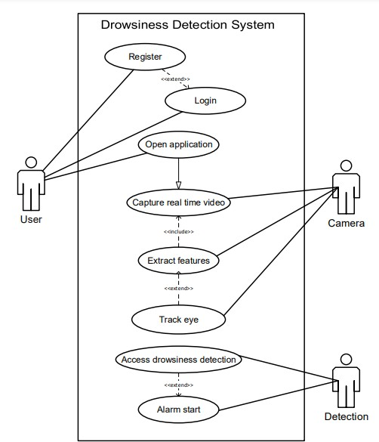

**ACTIVITY DIAGRAM FOR DRIVER DROWSINESS DETECTION**

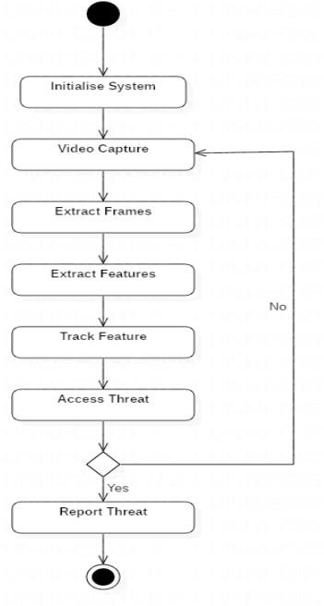

# CLASS DIAGRAM FOR DRIVER DROWISNESS DETECTION

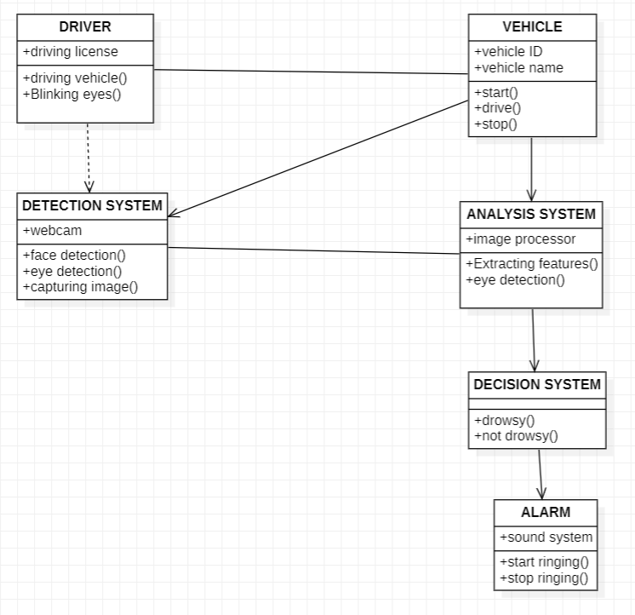

**PACKAGE DIAGRAM FOR DRIVER DROWSINESS DETECTION**

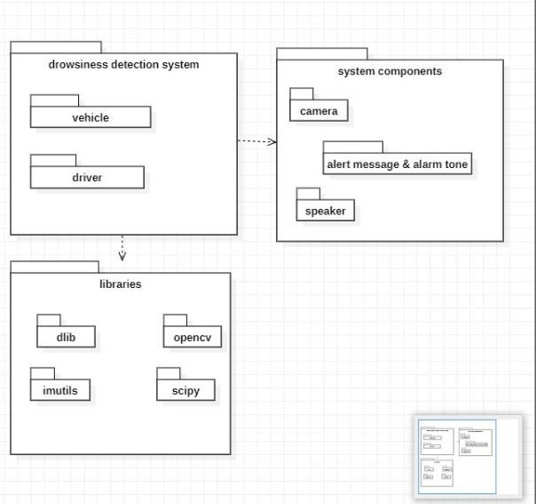

# IMPLEMENTATION

from scipy.spatial import distance from imutils import face_utils import imutils

import dlib import cv2

from playsound import playsound def eye_aspect_ratio(eye):

A = distance.euclidean(eye[1], eye[5]) B = distance.euclidean(eye[2], eye[4]) C = distance.euclidean(eye[0], eye[3]) ear = (A + B) / (2.0 * C)

return ear thresh = 0.25

frame_check = 20

detect = dlib.get_frontal_face_detector()

predict = dlib.shape_predictor("models/shape_predictor_68_face_landmarks.dat")# Dat file is the crux of the code

(lStart, lEnd) = face_utils.FACIAL_LANDMARKS_68_IDXS["left_eye"] (rStart, rEnd) = face_utils.FACIAL_LANDMARKS_68_IDXS["right_eye"] cap=cv2.VideoCapture(0)

flag=0 while True:

ret, frame=cap.read()

frame = imutils.resize(frame, width=450)

gray = cv2.cvtColor(frame, cv2.COLOR_BGR2GRAY) subjects = detect(gray, 0)

for subject in subjects:

shape = predict(gray, subject)

shape = face_utils.shape_to_np(shape)#converting to NumPy Array leftEye = shape[lStart:lEnd]

rightEye = shape[rStart:rEnd] leftEAR = eye_aspect_ratio(leftEye)

rightEAR = eye_aspect_ratio(rightEye) ear = (leftEAR + rightEAR) / 2.0 leftEyeHull = cv2.convexHull(leftEye) rightEyeHull = cv2.convexHull(rightEye)

cv2.drawContours(frame, [leftEyeHull], -1, (0, 255, 0), 1)

cv2.drawContours(frame, [rightEyeHull], -1, (0, 255, 0), 1) if ear < thresh:

flag += 1 print (flag)

if flag >= frame_check:

playsound('alarm.wav')

cv2.putText(frame, "****************ALERT!****************", (10, 30),

cv2.FONT_HERSHEY_SIMPLEX, 0.7, (0, 0, 255), 2)

cv2.putText(frame, "****************ALERT!****************", (10,325),

cv2.FONT_HERSHEY_SIMPLEX, 0.7, (0, 0, 255), 2)

else:

flag = 0

cv2.imshow("Frame", frame) key = cv2.waitKey(1) & 0xFF if key == ord("q"):

break cv2.destroyAllWindows() cap.release()

from playsound import playsound playsound('alarm.wav')

# STEPS TO RUN THE PROJECT

## STEP 1 :

Copy the path name where the file is stored and past it in command promt with the command Cd <path name>

## STEP 2 :

The next step is to open the dir in command prompt



## STEP 3 :

The third step is ,the list of directories is shown in command prompt

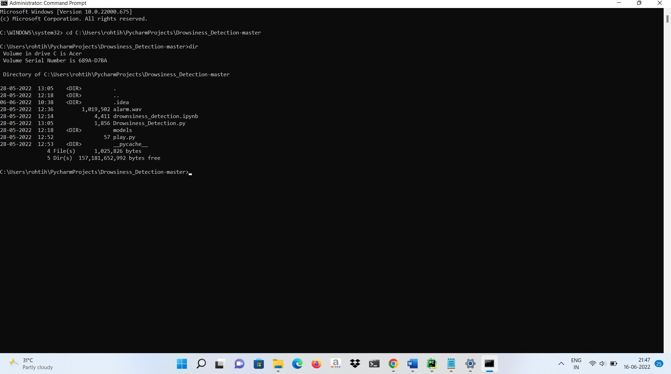

## STEP 4 :

Fourth step is to type the project file name with the command Python<python file name>

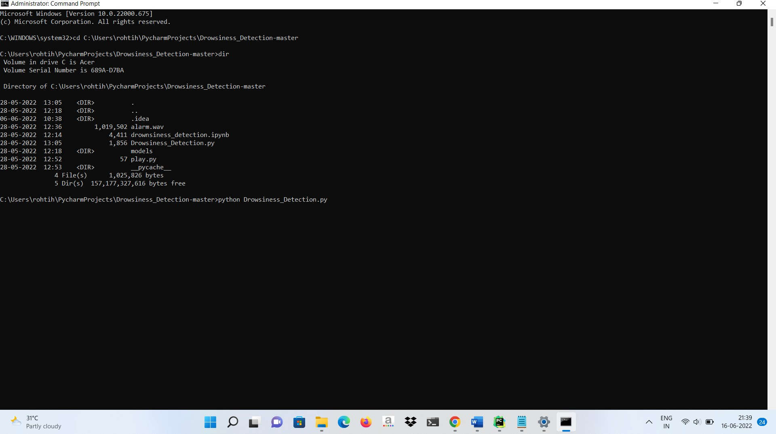

## OUTPUT :

Detecting the eye co ordinates

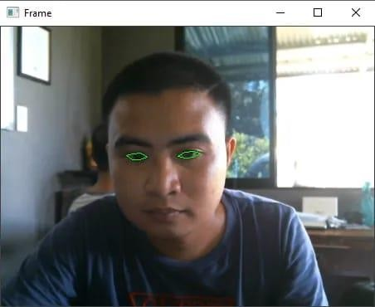

Alerts driver when he falls asleep

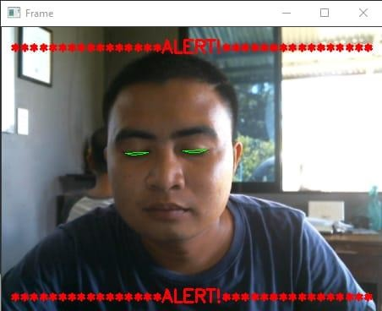

# CONCLUSION :

It completely meets the objectives and requirements of the system. The framework has achieved an unfaltering state where all the bugs have been disposed of. The framework cognizant clients who are familiar with the framework and comprehend it's focal points and the fact that it takes care of the issue of stressing out for individuals having fatigue-related issues to inform them about the drowsiness level while driving. The library's pre-trained 68 facial landmark detector is employed in this Dlib technique.The quantitative metric used in the proposed algorithm was the Eye Aspect Ratio (EAR) to monitor the Driver Drowsiness. The average real-time test accuracies obtained using Dlib for Eye Detection Accuracy was found to be 80.17% and Drowsiness Accuracy as found to be 78.50% The results of real-time detection are lower as the model currently works well under good lighting conditions. The driver abnormality monitoring system developed is capable of detecting drowsiness, drunken and reckless behaviours of driver in a short time. The Drowsiness Detection System developed based on eye closure of the driver can differentiate normal eye blink and drowsiness and detect the drowsiness while driving. The proposed system can prevent the accidents due to the sleepiness while driving. The system works well even in case of drivers wearing spectacles and even under low light conditions if the camera delivers better output. Information about the head and eyes position is obtained through various self-developed image processing algorithms. During the monitoring, the system is able to decide if the eyes are opened or closed. When the eyes have been closed for too long, a warning signal is issued. processing judges the driver’s alertness level on the basis of continuous eye closures

# FUTURE SCOPE:

The model can be improved incrementally by using other parameters like blink rate, yawning, state of the car, etc. If all these parameters are used it can improve the accuracy by a lot. We plan to further work on the project by adding a sensor to track the heart rate in order to prevent accidents caused due to sudden heart attacks to drivers. Same model and techniques can be used for various other uses like Netflix and other streaming services can detect when the user is asleep and stop the video accordingly. It can also be used in application that prevents user from sleeping.

## REFERENCES :

1. Hemant Kumar Dua , Sanchit Goel , Vishal Sharma,” Drowsiness Detection and Alert System”, IEEE International Conference on Advances in Computing, Communication Control and Networking, 2018, DOI:

10.1109/ICACCCN.2018.8748448

1. Jang Woon Baek, Byung-Gil Han, Kwang-Ju Kim, Yun-Su Chung, Soo-In Lee,” Real-time Drowsiness Detection Algorithm for Driver State Monitoring Systems”, IEEE Electronics and Telecommunications Research Institute, 2018, DOI: 10.1109/ICUFN.2018.8436988
2. Wisaroot Tipprasert, Theekapun Charoenpong, Chamaporn Chianrabutra, Chamaiporn Sukjamsri,” A Method of Driver’s Eyes Closure and Yawning Detection for Drowsiness Analysis by Infrared Camera”, IEEE First International Symposium on Instrumentation, Control, Artificial Intelligence, and Robotics (ICA-

SYMP),2019, DOI: 10.1109/ICA-SYMP.2019.8646001

1. Kumar A., & Patra R,”Driver drowsiness monitoring system using visual behaviour and machine learning”,IEEE Symposium on Computer Applications & Industrial Electronics (ISCAIE),2018, DOI:

10.1109/ISCAIE.2018.8405495

1. C. Kublbeck and A. Ernst, “Face detection and tracking in video sequence using the modified census transformation,” Image and Vision Computing, Vol. 24, pp. 564-572, 2006.
2. K. Ban, J. Kim, and H. Yoon, “Gender Classification of Low- Resolution Facial Image Based on Pixel Classifier Boosting,” ETRI Journal vol.38, no. 2, pp. 347-355. Apr. 2016.
3. P. Viola and M. Jones, "Rapid object detection using a boosted cascade of simple features," Proceedings of the

2001 IEEE Computer Society Conference on Computer Vision and Pattern Recognition. CVPR 2001, Kauai, HI,USA, 2001, pp. I-I